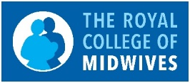
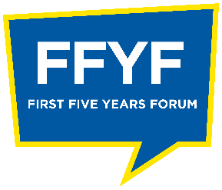
RCM SCOTLAND
FIRST FIVE YEARS FORUM
APPLICATION FORM
Current job title and band

NHS Board where employed

Permanent, fixed term or bank contract
Full or part time hours

Year qualified
RCM Membership number
University where studied Midwifery

Name and contact email for line manager
(Please confirm that you have discussed your application with them)

Additional study or continuing professional development since qualification

Have you completed flying start? Please give the date.

Can you describe your career development aspirations for the next five years
(250 words or less)
What would you bring to the RCM Scotland’s First Five year forum? What qualities, particular interests, expertise
(500 words or less)
What would you hope to gain from your involvement with FFYF?
(250 words or less)

For more information or to submit your application contact louise.leiper@rcm.org.uk
Closing date for submission is Friday 19th February 2021. All applications will be held in the strictest confidence and in line with GDPR.
All applicants will be contacted by email.

