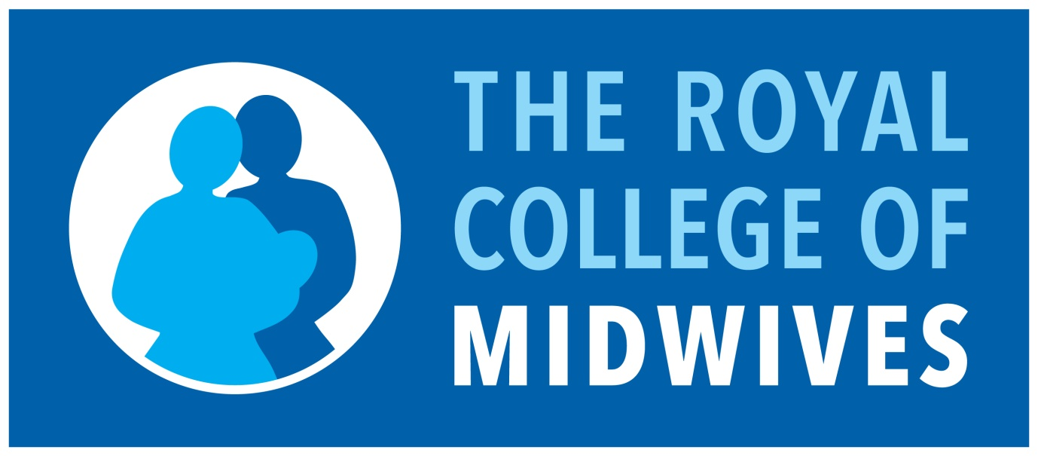

Reflective Model (Jenkins, 2007)

The situation
What happened? What did you think or feel about the situation? What factors contributed to the situation?

Reflection
What were you trying to achieve? What are the consequences of the situation, both good and bad? How has this affected the woman? How has this affected you?

Learning
What other choices did you have? What could you have done differently? With hindsight what would you change?

Summary
How do you feel now? What have you learnt? Has this been a positive or negative experience?

Consider the following questions to help guide the individual’s reflection for the objective.

- What aspects of this objective did you find interesting and why was this so?

- Were any aspects of this objective difficult to achieve and how did you overcome this?

- What did you as an individual experience and how was the experience for other members in the team in situations relating to achieving your objectives?

- Were there any factors which affected the team’s effectiveness (this can be both positive and negative considerations) relating to achieving your objectives?

- How can you ensure that you will be able to continue to demonstrate your objectives are being met?

- How do you plan to update your knowledge relating to maintaining and developing new objectives?

- Is it relevant to develop a higher proficiency level i.e. being able to teach clinical skills/concepts, etc?

