Name
Current job title and band
NHS Board where employed
Permanent, fixed term or bank contract
Full or part time hours
Year qualified
RCM Membership number
University at which midwifery studied
Name and contact email for line manager
Additional study or continuing professional development since qualification
Have you completed flying start? Please give the date.
Can you describe your career development aspirations for the next five years (in 250 words or less)
What would you bring to the RCM Scotland’s First Five year forum? What qualities, particular interests, expertise (in 500 words or less)
What would you hope to gain from your involvement with FFYF? (in 250 words or less)

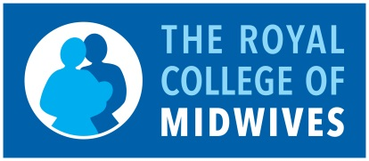
The RCM Scotland First Five Year’s Forum (‘FFYF’)
Application Form

